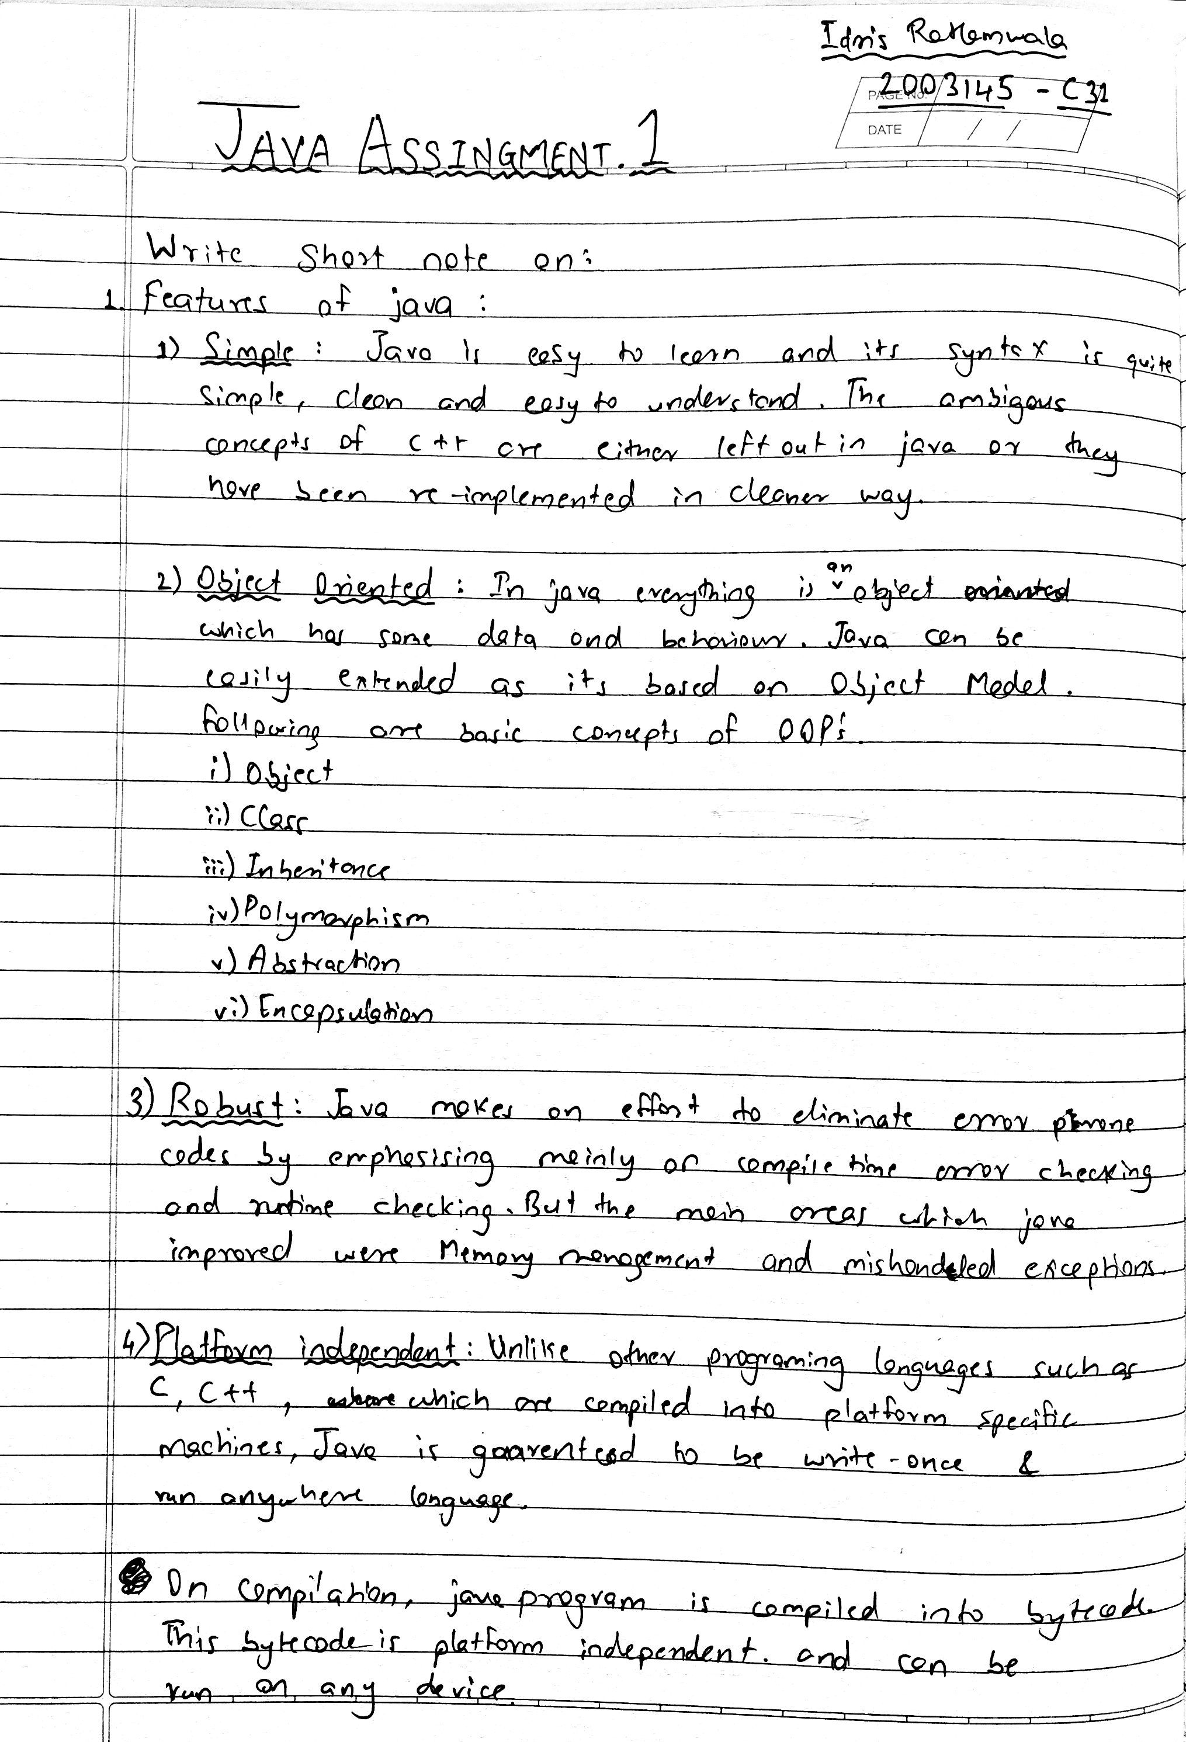

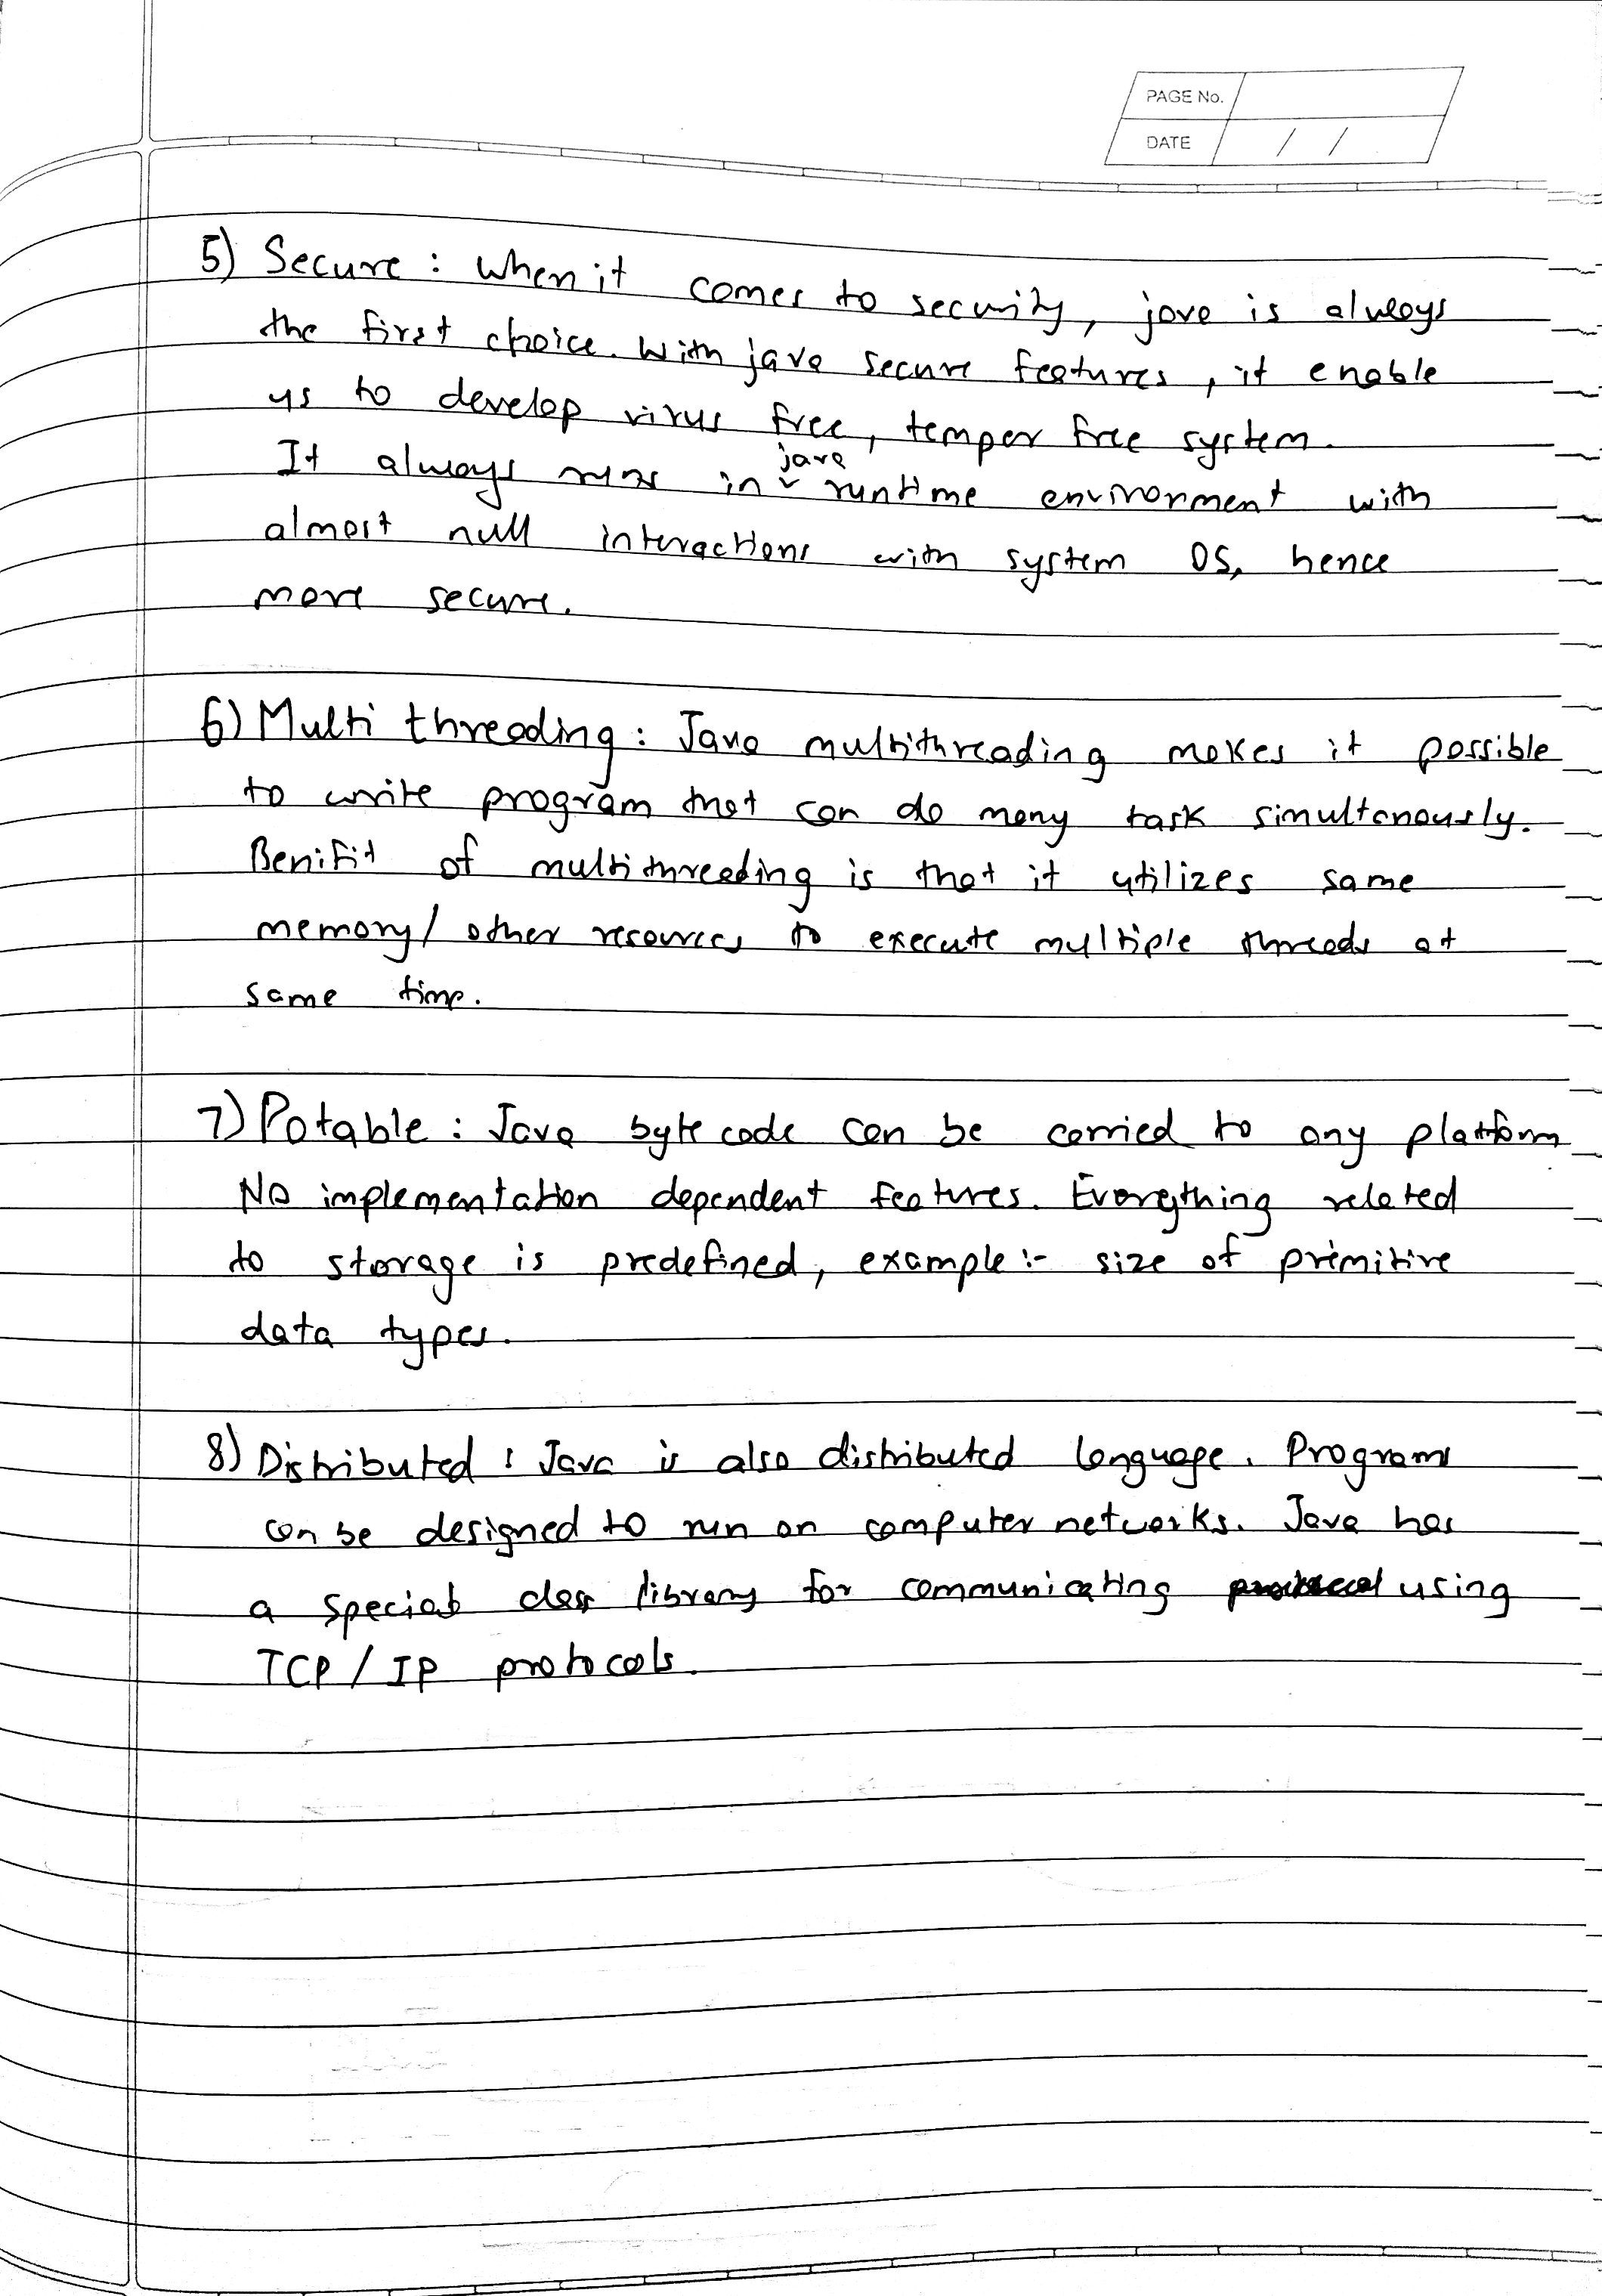

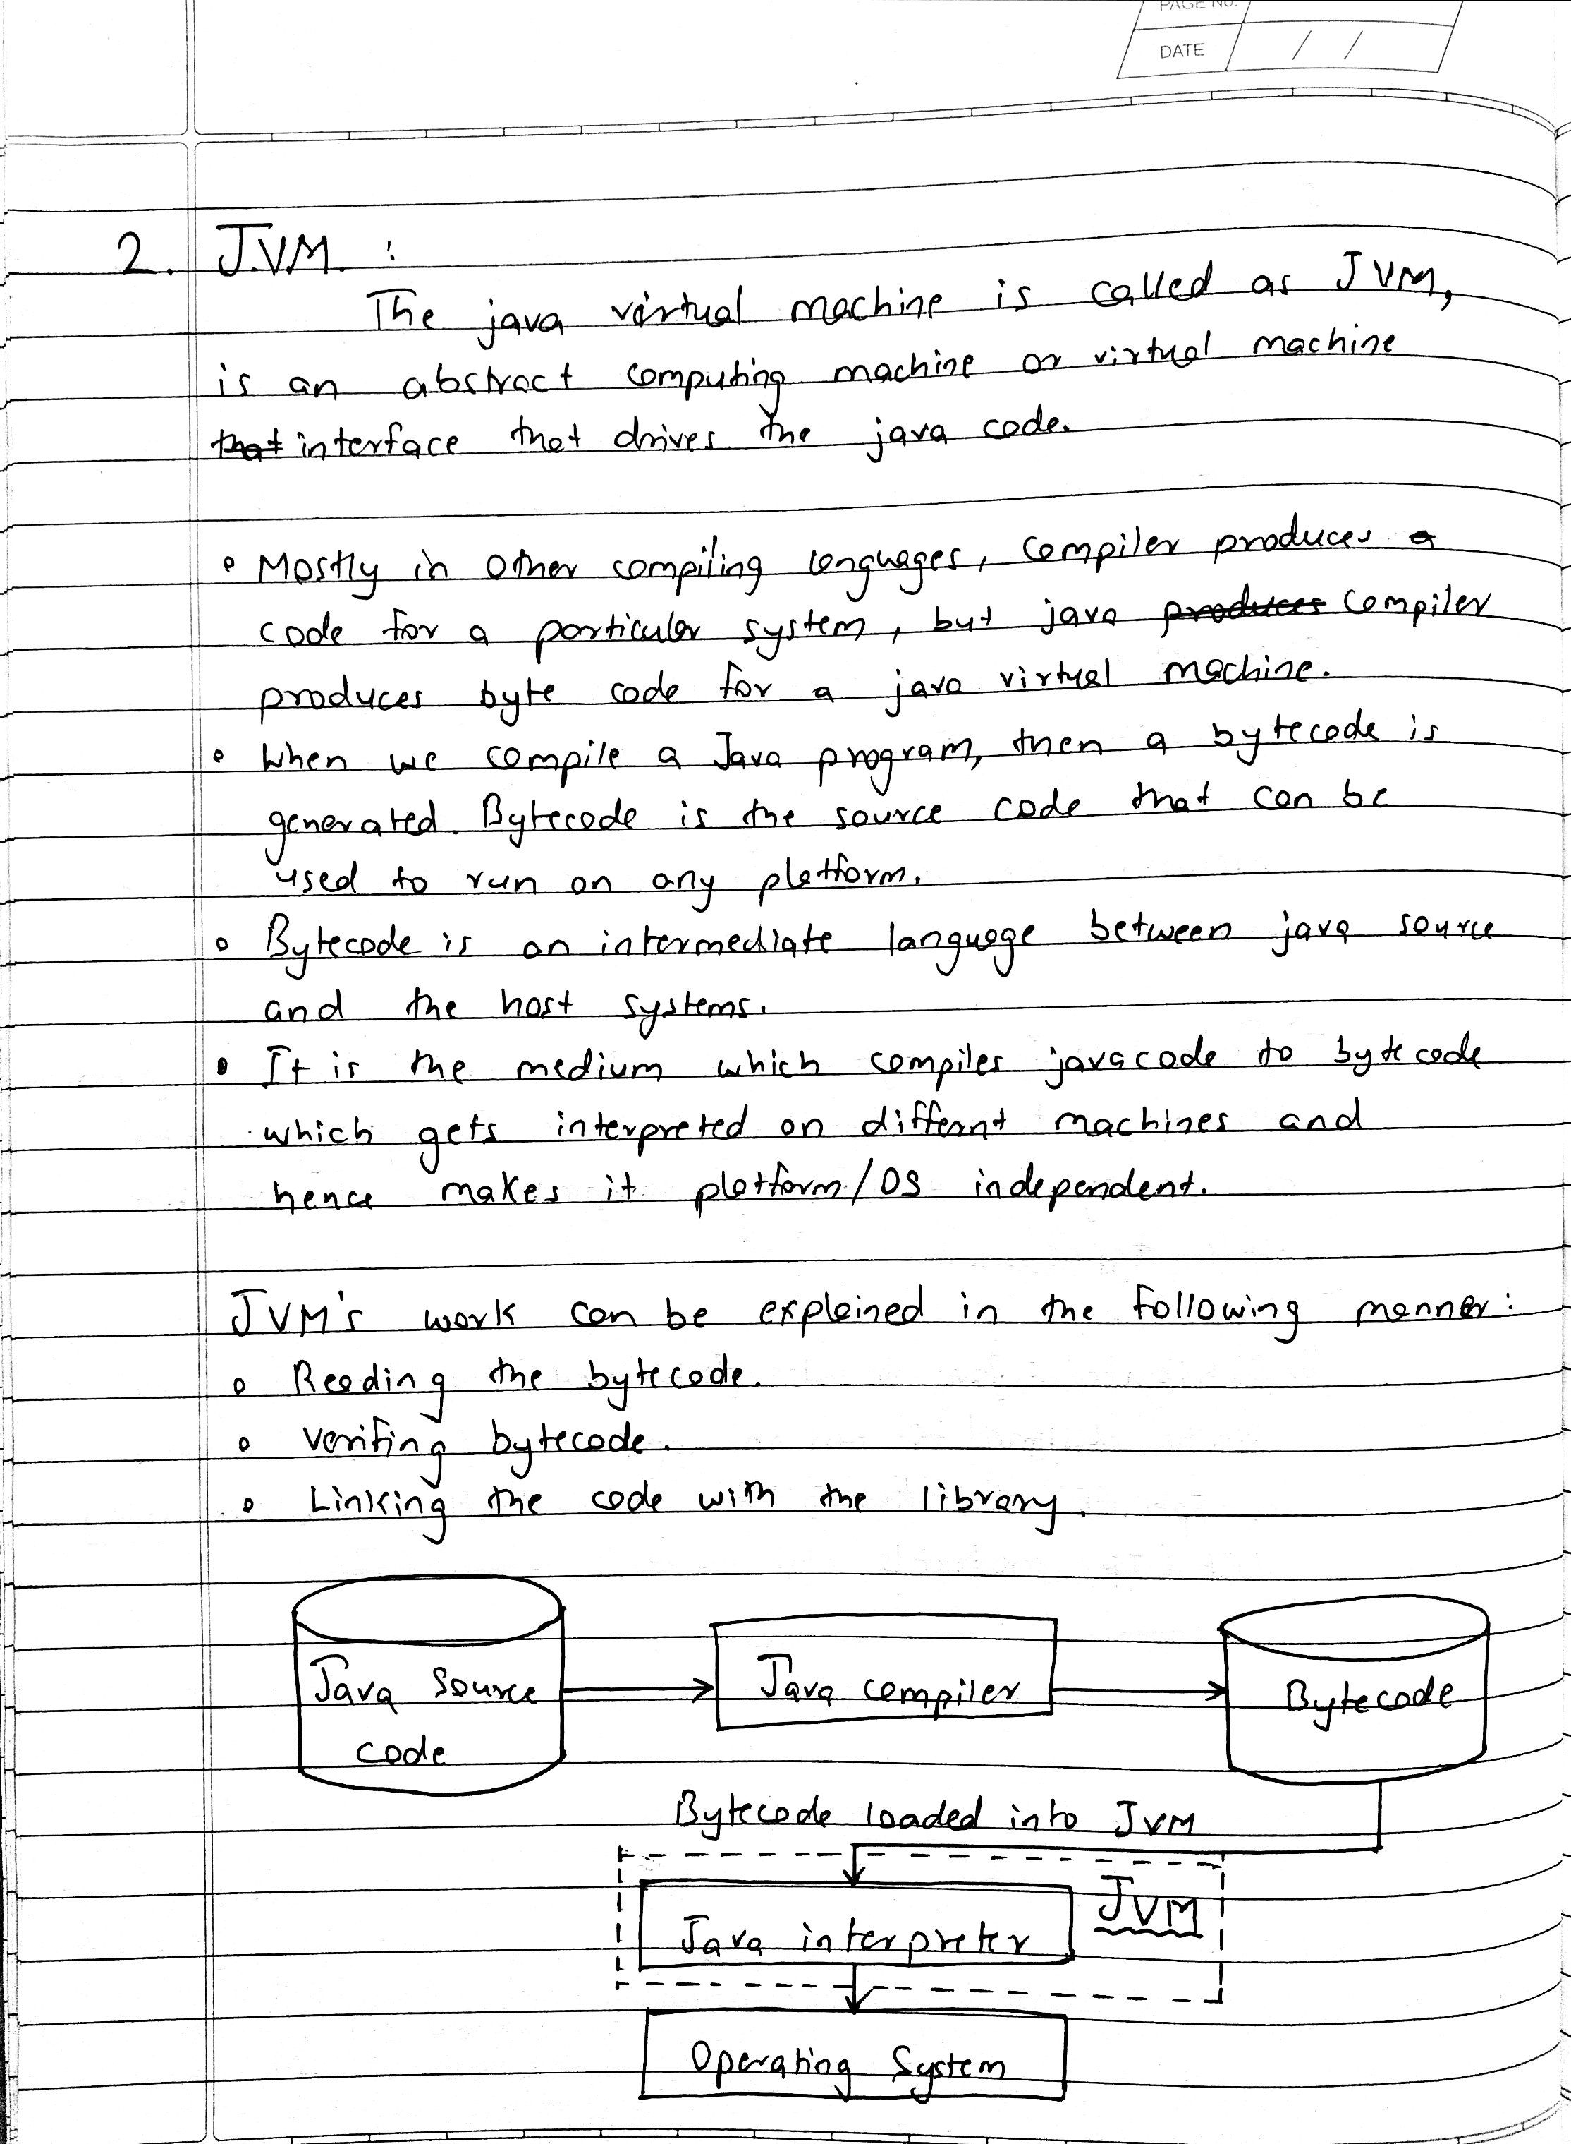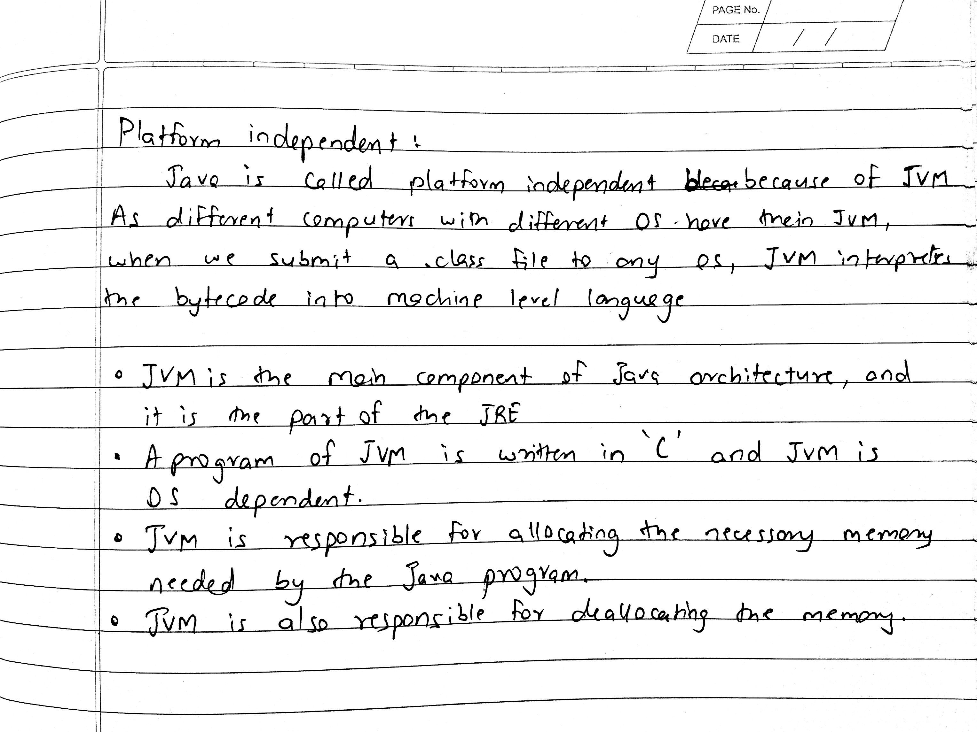

**3) Wrapper class :**

Java is an object-oriented programming language, so we need to deal with objects many times like in Collections, Serialization, Synchronization, etc. Let us see the different scenarios, where we need to use the wrapper classes.

* **Change the value in Method:** Java supports only call by value. So, if we pass a primitive value, it will not change the original value. But, if we convert the primitive value in an object, it will change the original value.
* **Serialization:** We need to convert the objects into streams to perform the serialization. If we have a primitive value, we can convert it in objects through the wrapper classes.
* **Synchronization:** Java synchronization works with objects in Multithreading.
* **java.util package:** The java.util package provides the utility classes to deal with objects.
* **Collection Framework:** Java collection framework works with objects only. All classes of the collection framework (ArrayList, LinkedList, Vector, HashSet, LinkedHashSet, TreeSet, PriorityQueue, ArrayDeque, etc.) deal with objects only.

The eight classes of the *java.lang* package are known as wrapper classes in Java. The list of eight wrapper classes are given below:

|  |  |
| --- | --- |
| **Primitive Type** | **Wrapper class** |
| boolean | [Boolean](https://www.javatpoint.com/java-boolean) |
| char | [Character](https://www.javatpoint.com/post/java-character) |
| byte | [Byte](https://www.javatpoint.com/java-byte) |
| short | [Short](https://www.javatpoint.com/java-short) |
| int | [Integer](https://www.javatpoint.com/java-integer) |
| long | [Long](https://www.javatpoint.com/java-long) |
| float | [Float](https://www.javatpoint.com/java-float) |
| double | [Double](https://www.javatpoint.com/java-double) |

## **Autoboxing**

The automatic conversion of primitive data types into its wrapper class objects is known as autoboxing.

class Autoboxing {  
    public static void main( String args[] ) {  
     int a = 15; // Primitive data type  
     Integer I = a; // Autoboxing will occur internally.  
    }  
}

## **Unboxing**

The automatic conversion of wrapper class objects into its primitive data types is known as unboxing.

class Autoboxing {  
    public static void main( String args[] ) {  
      Integer a = new Integer(15); // Wrapper class object  
      int I = a;// Unboxing will occur internally.  
    }  
}

**4) Life cycle of a thread :**

Below diagram shows different states of thread life cycle in java. We can create a thread in java and start it but how the thread states change from Runnable to Running to Blocked depends on the OS implementation of thread scheduler and java doesn’t have full control on that.

[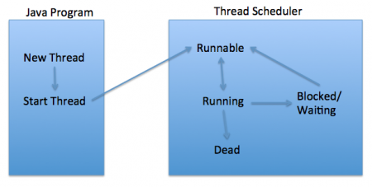](https://www.journaldev.com/wp-content/uploads/2012/12/Thread-Lifecycle-States.png)

### **New**

When we create a new Thread object using new operator, thread state is New Thread. At this point, thread is not alive and it’s a state internal to Java programming.

### **Runnable**

When we call start() function on Thread object, it’s state is changed to Runnable. The control is given to Thread scheduler to finish it’s execution. Whether to run this thread instantly or keep it in runnable thread pool before running, depends on the OS implementation of thread scheduler.

### **Running**

When thread is executing, it’s state is changed to Running. Thread scheduler picks one of the thread from the runnable thread pool and change it’s state to Running. Then CPU starts executing this thread. A thread can change state to Runnable, Dead or Blocked from running state depends on time slicing, thread completion of run() method or waiting for some resources.

### **Blocked/Waiting**

A thread can be waiting for other thread to finish using thread join or it can be waiting for some resources to available. For example producer consumer problem or waiter notifier implementation or IO resources, then it’s state is changed to Waiting. Once the thread wait state is over, it’s state is changed to Runnable and it’s moved back to runnable thread pool.

### **Dead**

Once the thread finished executing, it’s state is changed to Dead and it’s considered to be not alive.

Above are the different **states of thread**. It’s good to know them and how thread changes it’s state. That’s all for thread life cycle in java.